Unit 1: Types and Sources of Data and an Introduction to R
Task 1: Showing what I did using R
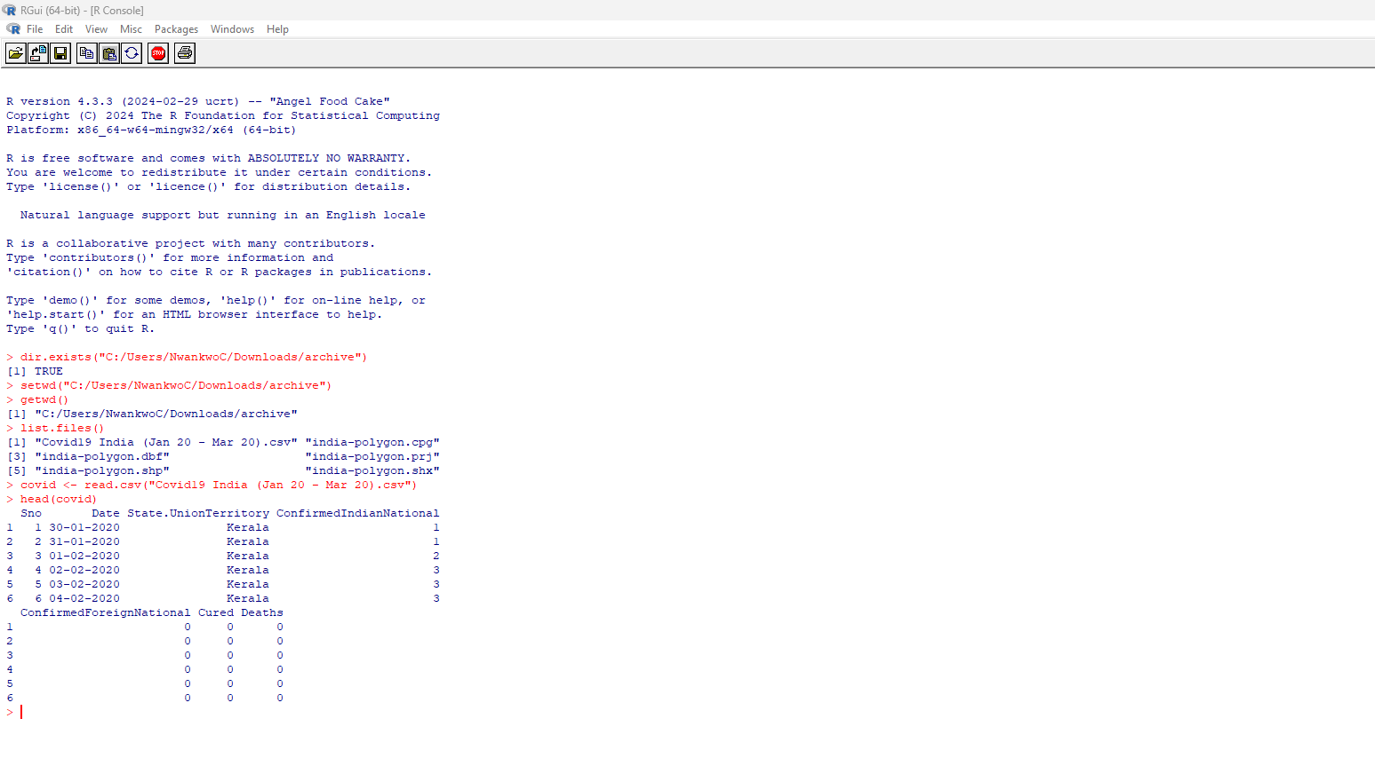
Number of columns - ncol(covid) = 7 Number of Rows - nrow(covid) = 270
Variable names - names(covid) Structure (shows data types)

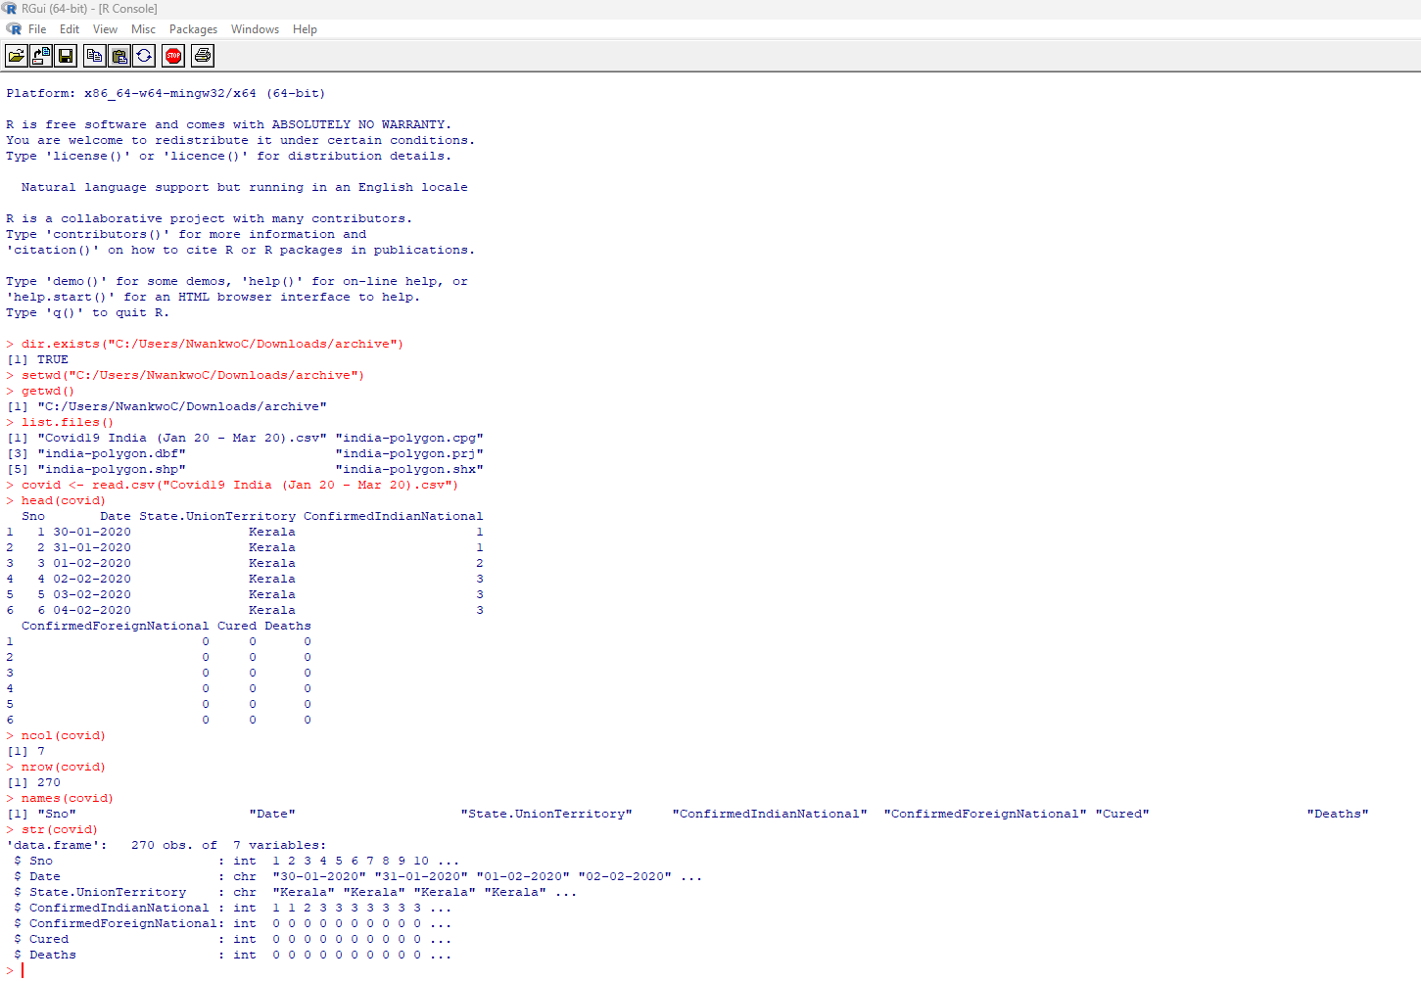
Number of Numeric variables: sum(sapply(covid, is.numeric))- 5, Number of character variables: sum(sapply(covid, is.character)) – 2
Number of date variables : sum(sapply(covid, inherits, "Date")) – 0, Checking column names first - names(covid)

Task 1.2
Unique states: length(unique(covid$State.UnionTerritory)) – 27
Convert dates using: covid$Date <- as.Date(covid$Date, format="%d-%m-%Y") then ran: range(covid$Date)
Most frequent state: names(which.max(table(covid$State.UnionTerritory))) – Kerala
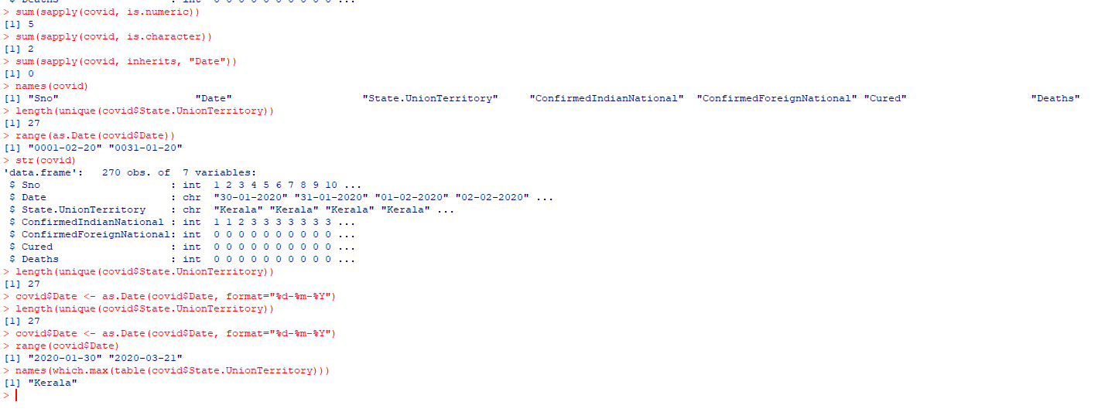

Question | Answer
How many total variables (columns) are in this dataset? | 7
How many total observations (rows) are in this dataset? | 270
What are the names of all variables? | Sno, Date, State.UnionTerritory, ConfirmedIndianNational, ConfirmedForeignNational, Cured, Deaths
How many variables are numeric? | 5
How many variables are character/text? | 2
How many variables are date format? | 0
How many unique states/union territories are represented? | 27
What is the date range? | 30 January 2020 – 21 March 2020
Which state appears most frequently? | Kerala

